Assignments on Junit

1. Write a class called MinMaxFinder. Define a method in it called findMinMax() which accepts an int array and returns new array of size 2, wherein the 0th index will have the min value of the array and 1st index will have max value of the array. Perform Junit testing of the method findMinMax with as many test cases you can think of (min 3 test cases)

E.g.

MinMaxFinder.findMinMax( new int[]{56, 34, 7,3, 54, 3, 34, 34, 53} ); should return a new array with min and max values {3, 56} at 0th and 1st index respectively

CODE :

import java.util.Arrays;  
  
class MinMaxFinder{  
  
 public int[] findMinMax(int[] arr){  
 int[] ans = new int[2];  
  
 Arrays.*sort*(arr);  
  
 ans[0] = arr[0];  
 ans[1] = arr[arr.length-1];  
 return ans;  
 }  
}

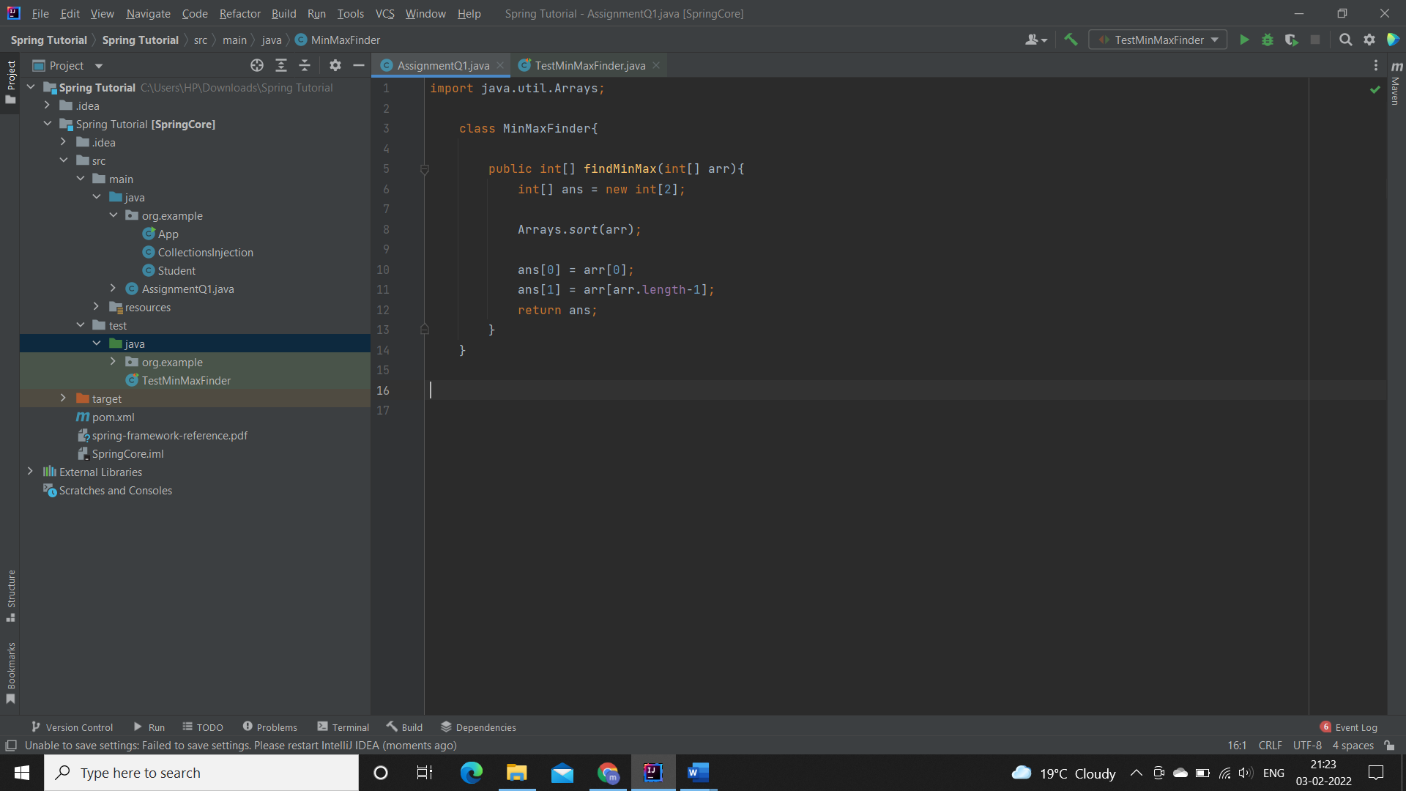

**Add the above in src/test/java/TestMinMaxFinder.java file as**

**below:**

import org.junit.jupiter.api.AfterEach;  
import org.junit.jupiter.api.Assertions;  
import org.junit.jupiter.api.BeforeEach;  
import org.junit.jupiter.api.Test;  
  
public class TestAssignment1 {  
  
 private MinMaxFinder minMaxFinder;  
 private int[] expected;  
 private int[] actual;  
  
 @BeforeEach  
 public void init(){  
 minMaxFinder = new MinMaxFinder();  
 expected = new int[]{3, 56};  
 }  
  
 @Test  
 public void TestminMaxFinder(){  
 actual = minMaxFinder.findMinMax(new int[]{56, 34, 7,3, 54, 3, 34, 34, 53});  
 Assertions.*assertArrayEquals*(expected,actual);  
 }  
  
 @AfterEach  
 public void Clean(){  
 minMaxFinder = null;  
 expected = actual = null;  
 }  
}

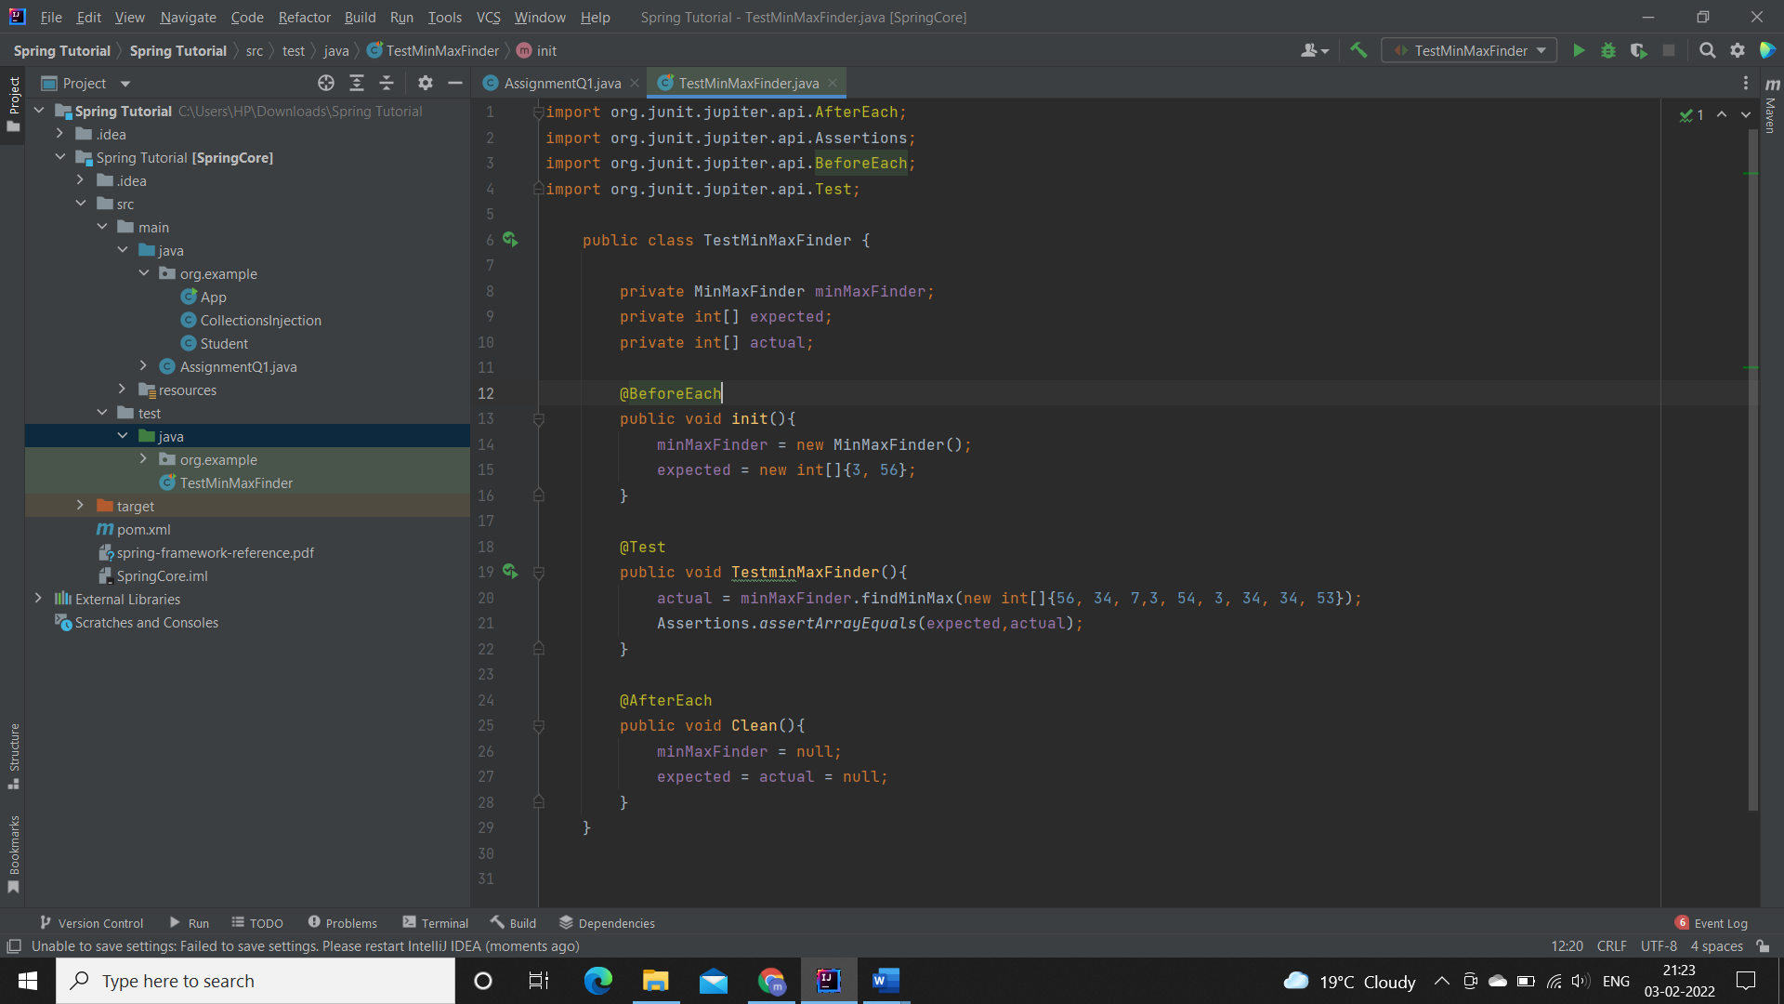

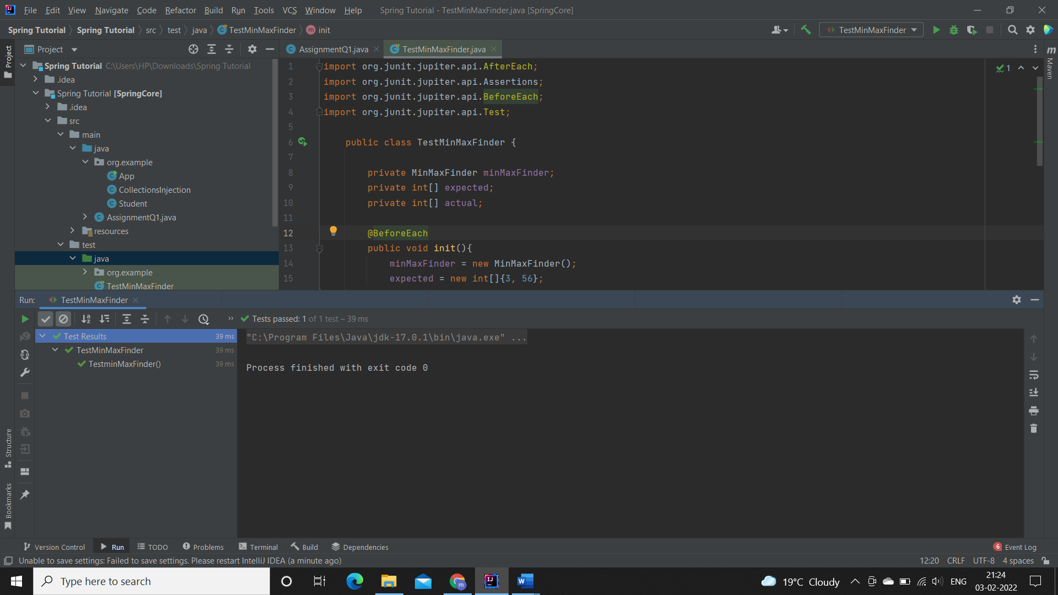OUTPUT:

1. Modify the above method to return a single object representing min and max value of the pass array. Define new sets of Junit Test cases of this modified method.

Code:

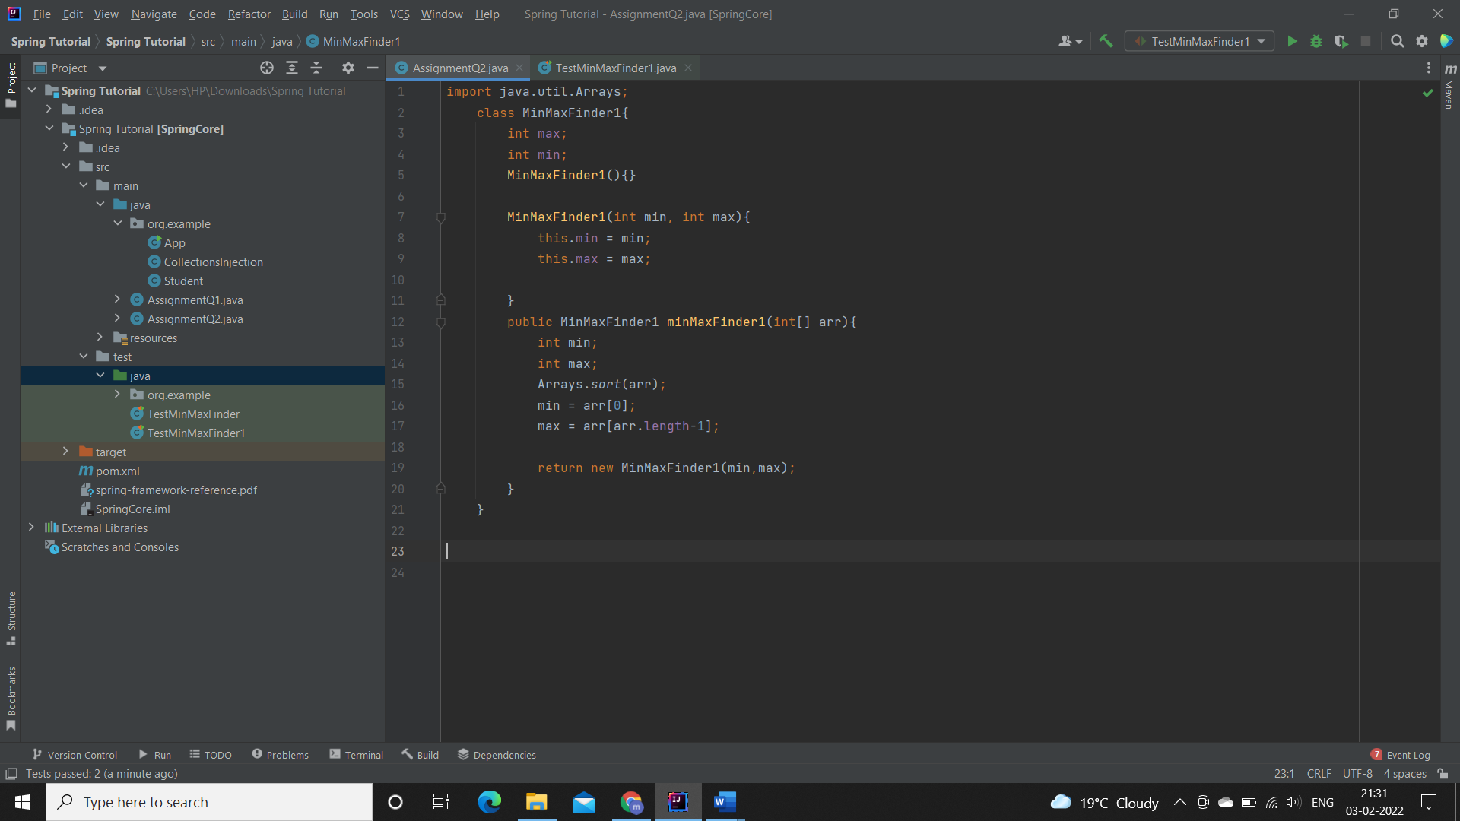

**Add the above in src/test/java/TestMinMaxFinder1.java file as below:**

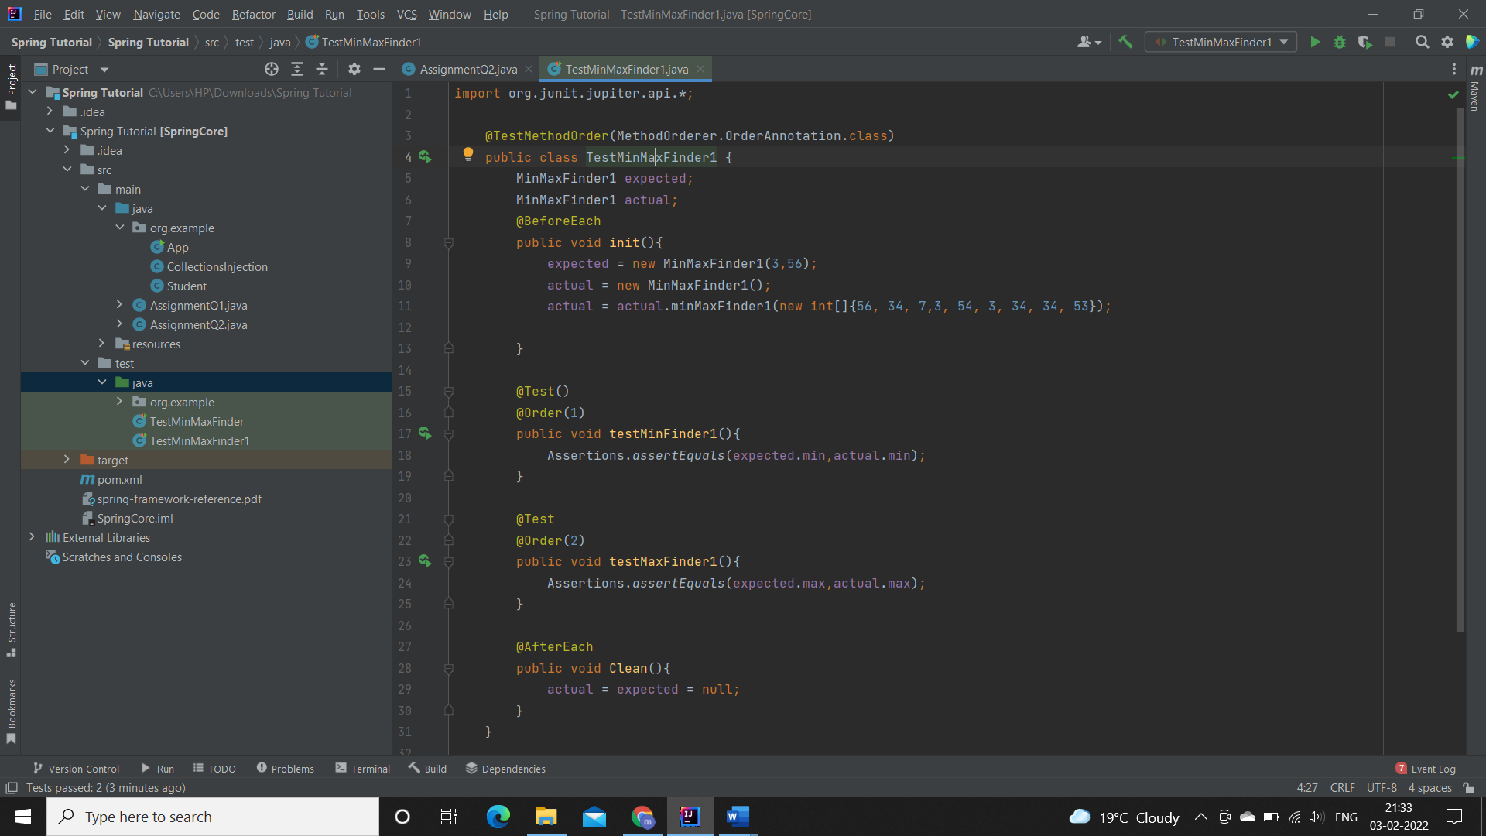

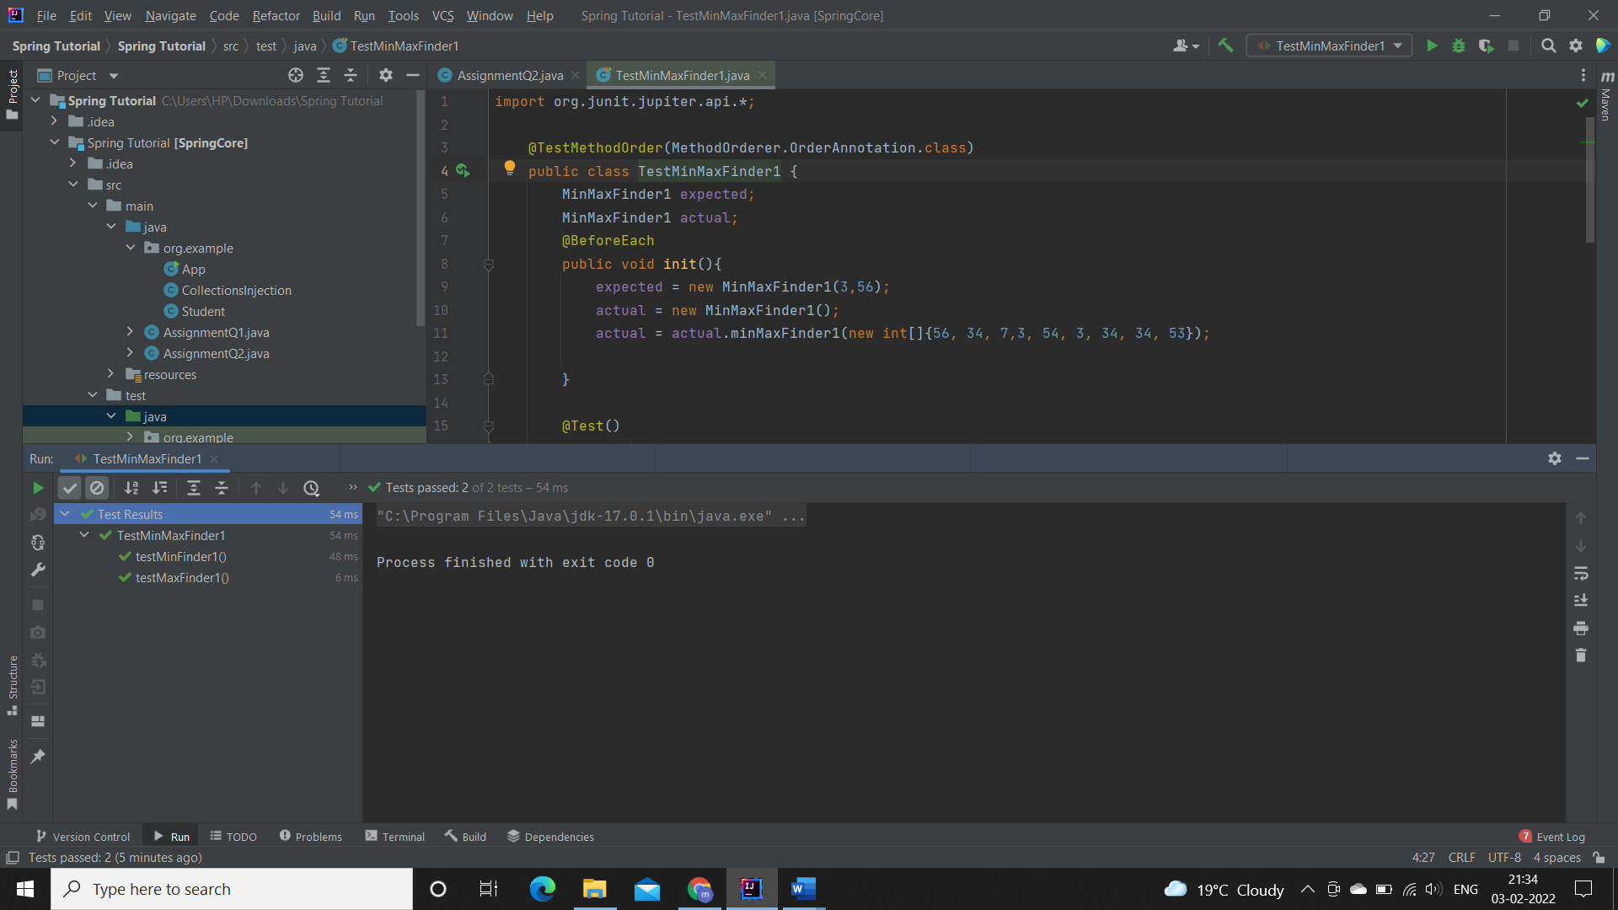OUTPUT:

1. Write a BankAccount class with method withdraw which accepts amount to be withdrawn from the account (amount to be deducted from the balance of the account). In case there are insufficient funds a InsufficientFundsExpcetion should be raised. After defining the method perform Junit testing to check whether the InsufficientFundsException is raised when you try to withdraw amount that is over and above the account balance.

bankAccount.withdraw(20,000); should raise the InsufficientFundsException if the balance in the account is less than 20,000.

Code:

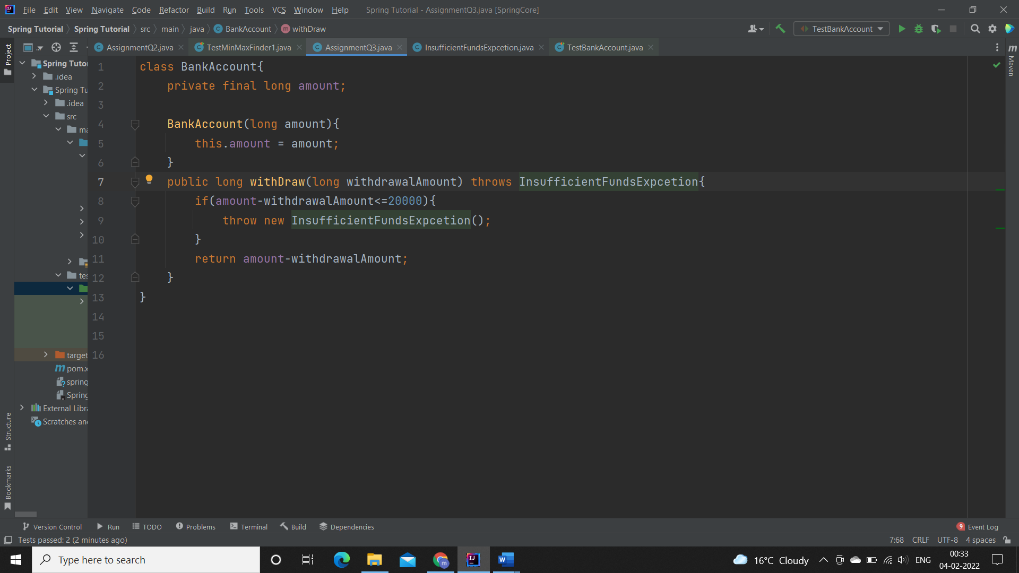

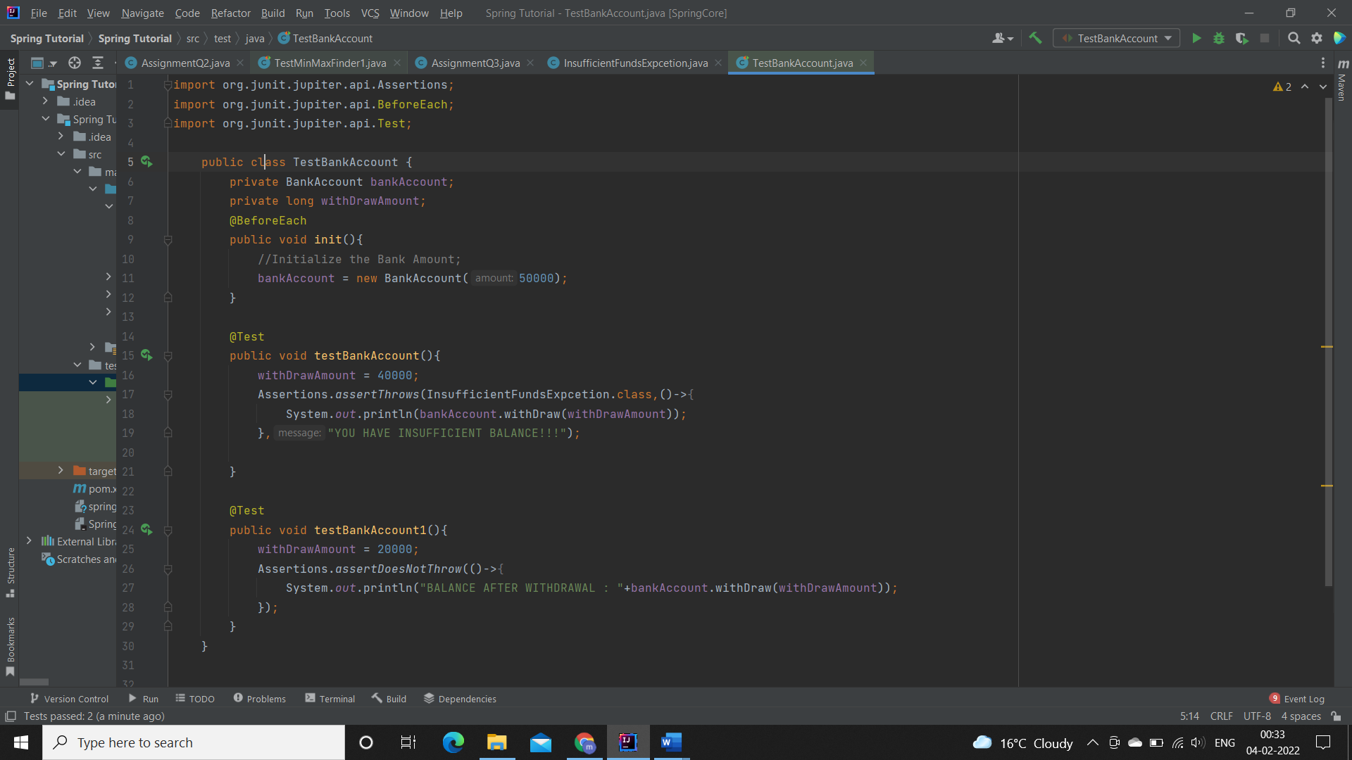

Output:

